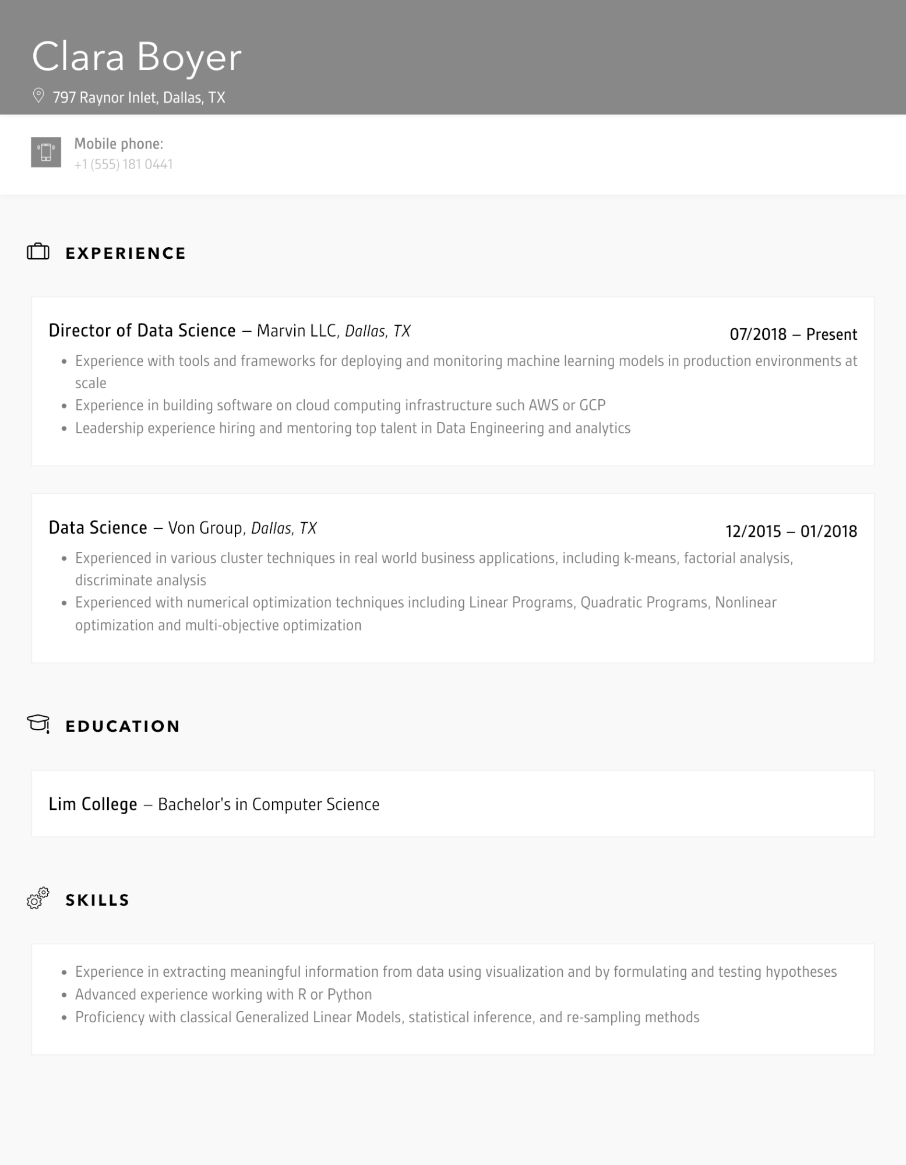
Clara Boyer
797 Raynor Inlet, Dallas, TX
Mobile phone:
+1 (555) 181 0441
EXPERIENCE
Director of Data Science - Marvin LLC, Dallas, TX
•
07/2018 - Present
Experience with tools and frameworks for deploying and monitoring machine learning models in production environments at scale
Experience in building software on cloud computing infrastructure such AWS or GCP Leadership experience hiring and mentoring top talent in Data Engineering and analytics
Data Science - Von Group, Dallas, TX
•
•
12/2015 01/2018
Experienced in various cluster techniques in real world business applications, including k-means, factorial analysis, discriminate analysis
Experienced with numerical optimization techniques including Linear Programs, Quadratic Programs, Nonlinear optimization and multi-objective optimization
EDUCATION
Lim College - Bachelor's in Computer Science
SKILLS
•
•
Experience in extracting meaningful information from data using visualization and by formulating and testing hypotheses Advanced experience working with R or Python
Proficiency with classical Generalized Linear Models, statistical inference, and re-sampling methods

